Type | Map | Uses / Characteristics  Levels of Distorted/Conformal
1  Robinson | 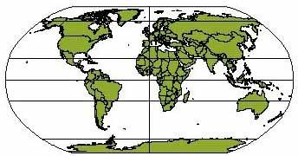 | Areas near the poles appear flatter than reality. Land is fairly accurate in size and shape, especially on the eastern and western edges.
2  Mercator | 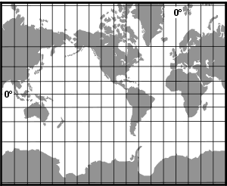 | Greatly exaggerates the high latitudes countries. Direction is accurate on the map. Images near the poles appear much bigger than reality. Shapes are accurate sizes are not.
3  Goode’s Interrupted or | 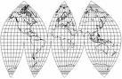 | Portray areas in the earth’s surface as their true proportion. Used for compare and contrast of land area regarding size.
4  Choropleth | 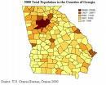 | Shows geographical information and intensity level over an area using pattern or color for each unit of representation.
5  Dot Distribution or Density Map | 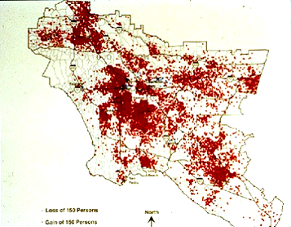 | Uses dots to show the distribution of particular criteria over an area. Dots do not show actual location of the criteria but the density of the criteria in that region.
6  Proportional Symbol | 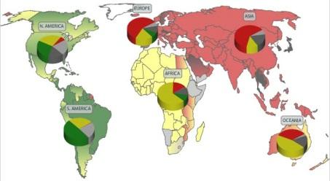 | Shows the number of things in a particular area using the symbol scaled to represent the data.
lesson created by S. Kotkin – modified by P. Gray

Type | Map | Uses / Characteristics
7  Cartogram | 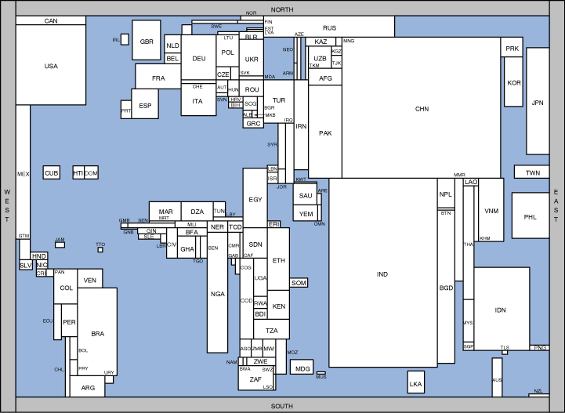 | Size of the units is proportional to the data represented. Used to represent statistics such as political turnout or population density.
8  Isopleth or Isarithmic Map | 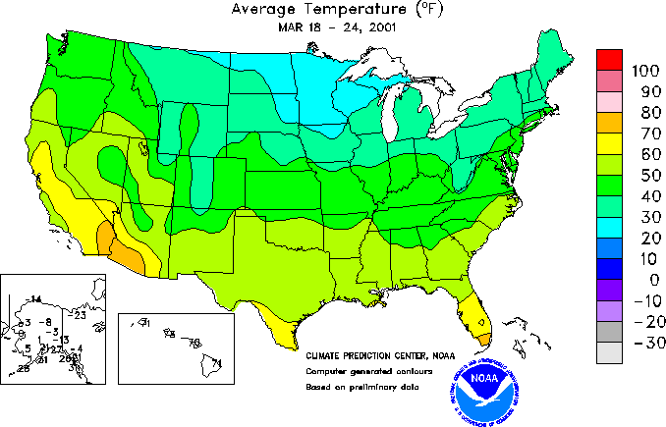 | This type of map is ideal for showing gradual change over space. Temperature is a phenomenon that should be mapped using isopleth. Relief maps should always be in isopleth form for this reason.
9  Sinusoidal | 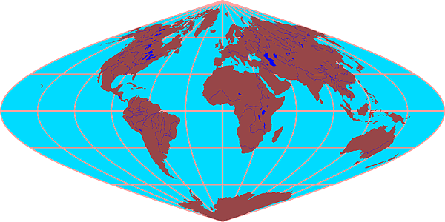 | Excellent for reference
10  Mollweide | 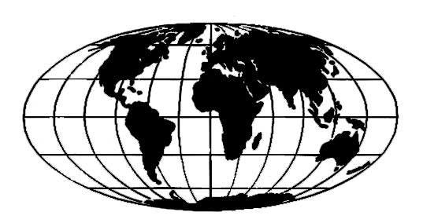 | Excellent for reference
11  Flow Line Map | 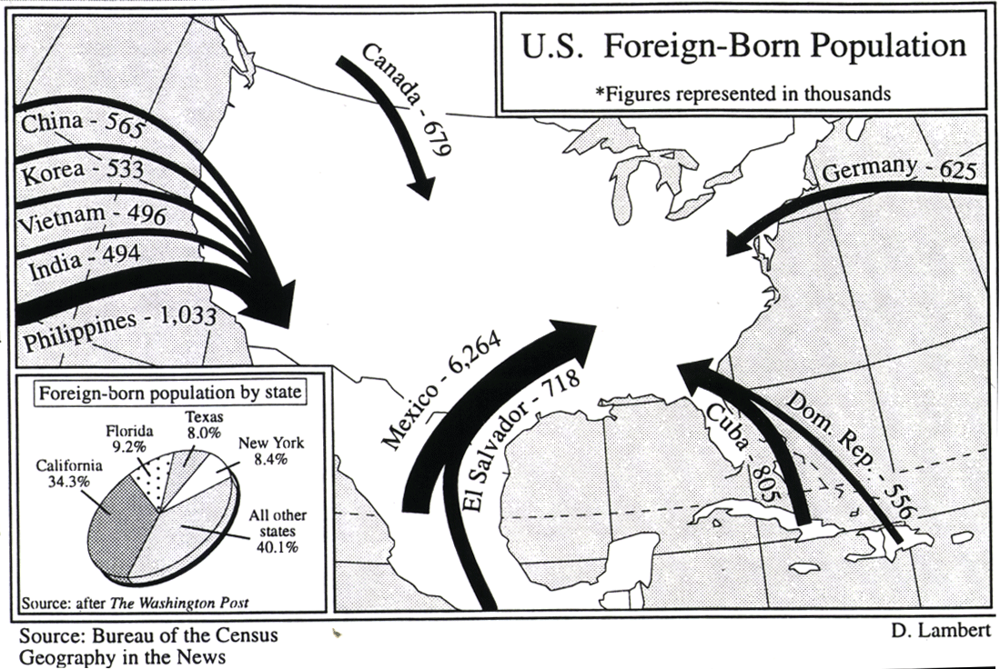 | Lines show direction of movement of phenomena. Thickness of lines show amount of what is being measured
- lesson created by S. Kotkin – modified by P. Gray

