Outlines, Note taking and Reading the Chapters in APHG

Chapter Outlines
You will produce a handwritten outline over the chapter readings assigned to you in class. Outlines will receive a completion grade. These notes may be used on the quiz associated with these readings. Outlines are NOT class notes. These are separate items. The bottom line – a good outline equals good quiz scores.
Don’t be a Medieval Monk!!!!
Medieval monks copied texts because there were no copy machines or computers! You don’t have that problem. Never write something down unless you can put it in your own words. It’s okay to copy a definition of a highlighted term down if you want. But, then write it down in your own words after you analyze what it is saying. The bottom line – if you can’t put something in your own words, you don’t know what it means!!

You don’t have to think about these terms too much.
In human geography, there are many terms that truly define themselves. Therefore, don’t kill yourself trying to make the perfect definition. For example, double cropping, multi-national corporation, ethnic neighborhood and high-technology corridors are examples of terms which don’t need much explaining.

Don’t You EVER, EVER, EVER use the GLOSSARY
The glossary is NOT a good place to learn vocabulary! Why? Because the glossary has the definitions isolated without CONTEXT or EXAMPLES. Vocabulary words are essential to what you need to learn; however, they must be read, understood and learned in CONTEXT and with appropriate EXAMPLES. This happens in the reading of the text – not the glossary.

As you read, ask yourself, “What is the most important word or words in a sentence, sentences or paragraph.” You might think of this as “distilling.” Can you distill a paragraph down into a sentence that contains all of the most important information. Or, think about a sieve or funnel:

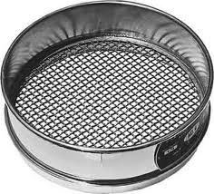

Think about “pouring all you have read” into that sieve or funnel. You want only the most important stuff coming out of the bottom. Remember, if you read something and it is common sense or you already know it – you don’t necessarily need to put it in your notes. Again, use common sense.

To Boldly Go Where No Student Has Gone Before
Bold and Italicized Words – these words are always important for quizzes and tests. So, having them in an outline is important. You must put at least one example with these terms (where applicable). In other words, what does this term mean in the real world?

It’s not just about vocabulary either! Pouring all of the text through our sieve above should help you think about THE BIG IDEAS in the text.

Finally, a good AP teacher can only get to about 80-90% of the material to be covered for an AP Exam. So, having students read texts can help us “cover” as many bases as we can.
Maps
Have you ever been reading book or text and skipped the pages with a map on it? Well, don’t do that in here. Maps are more important than the texts in many ways. In fact, if you use maps and other spatial data regularly, you will make your hippocampus grow! Critically analyze, think and play “Where’s Waldo?” on the maps. In fact, many of your chapter readings will have pages that are only map items. For example, let’s look the maps on pages 2-3, 23 and 138 to look at and interpret some maps with good stuff – and some with some mapping problems.

Note Taking
With Common Core expectations, this is not optional anymore.
Cornell Notes work very well – the most important step is to summarize what you have noted.
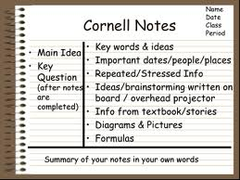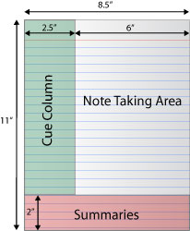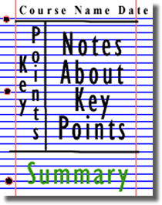

But you can use whatever format makes sense to you

Study Skills
A little bit each day means not much the night before. Most students cram for an exam. Try looking at what was done in class for 10-15 minutes each day. It doesn’t seem like much, but do the math. If you did this for three weeks, look at the numbers:

12.5 minutes x 21 days = 262.5 minutes
262.5/60 (minutes in an hour) = 4.375 hours
How many of you study 4+ hours the night before an exam????
Make college an 8-5 job!

Do you want to be successful in college AND have a lot fun? You really can do both. Just make college an 8-5 job. I will explain the details that will make college fun – and you will be successful, too!
Don’t Take it Home!!

Hardly anyone ever listens to this one. Use your school time wisely. If you get 5 minutes free in a class, use it! If you finish an exam in a class 25 minutes before the bell, be prepared. Have an assignment or something you need to read with you. Use that time to get done what needs to be done.

*Adapted from the work of Silver, H., Strong, R.W. & Perini, M.J. – Tools for Promoting Active, In-Depth Learning

