World History
Spetzler
Study Guide: Unit One

Identification: Who? What? Where? Why Important?

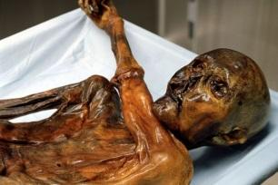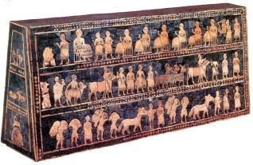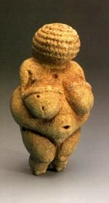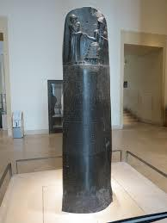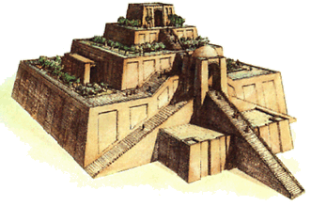
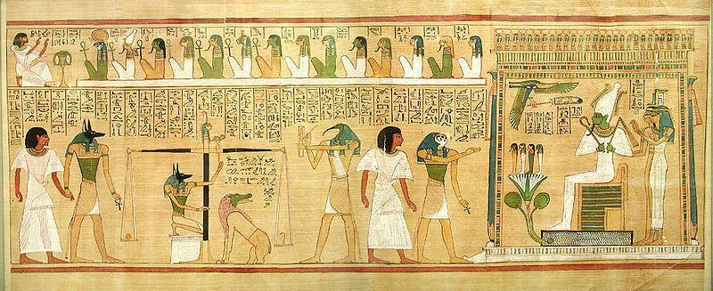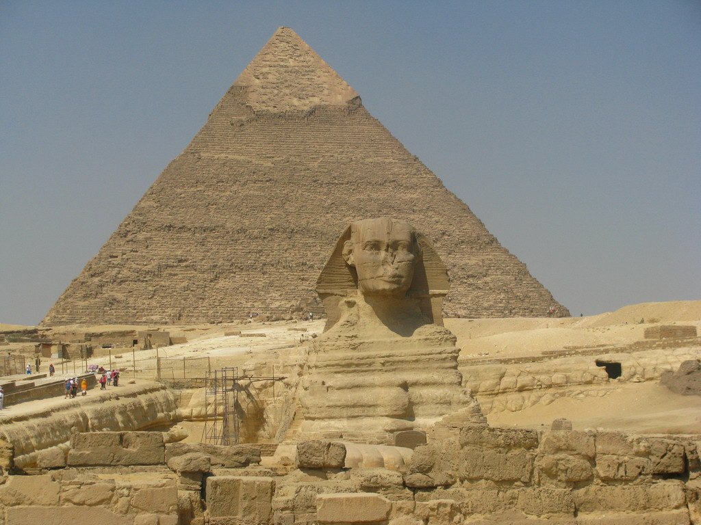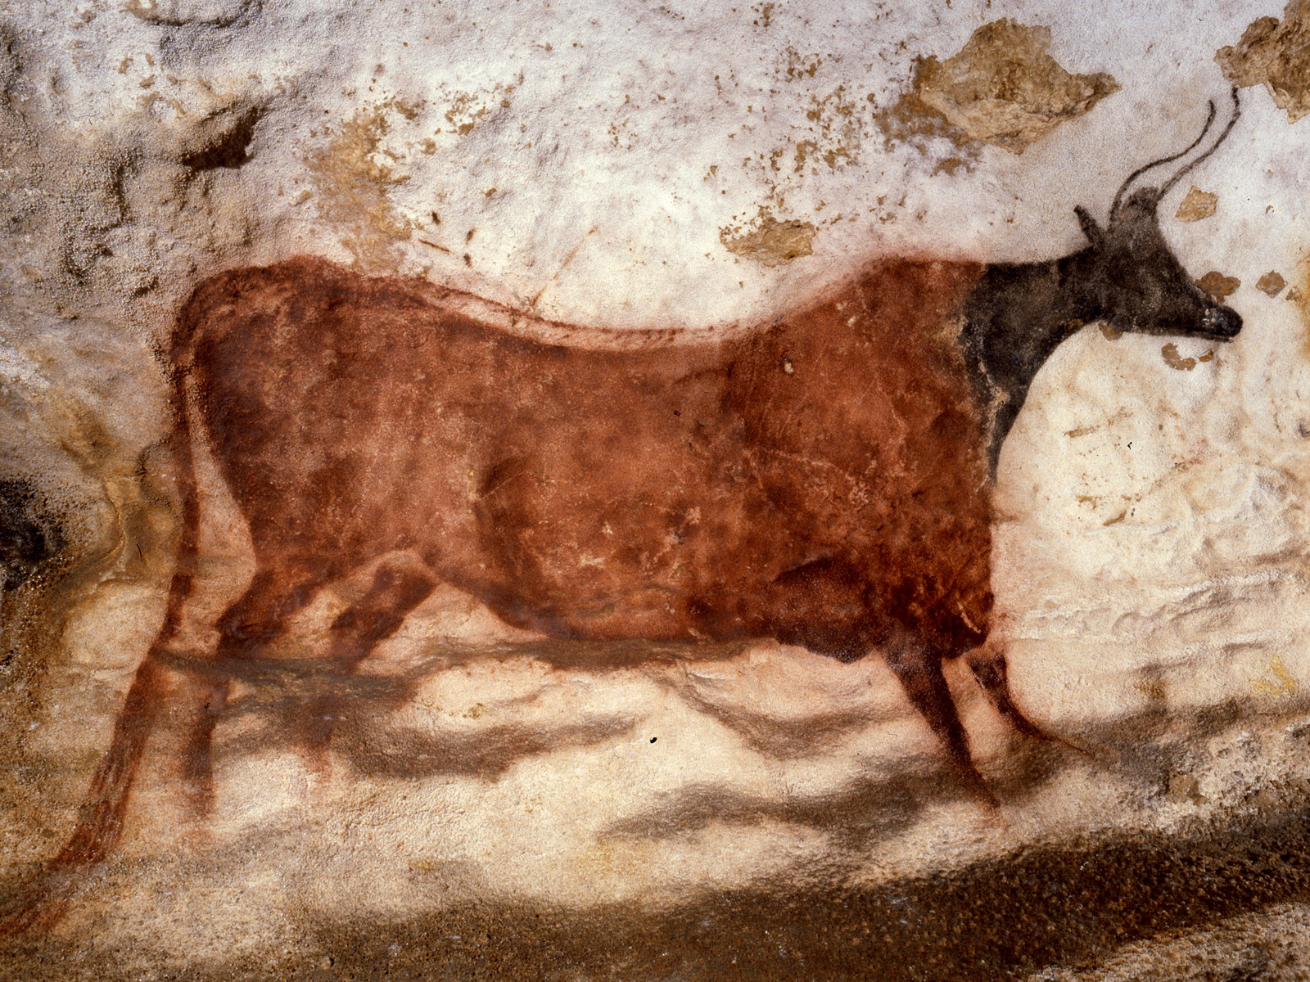
People, Places, Events, Concepts

Paleolithic Mesolithic Neolithic Revolution Carbon Dating Stratigraphy Fossil Artifact

Homo Erectus Neanderthals Homo Sapiens Sapiens “Out of Africa” Theory

Catal Huyuk Jerico Mesopotamia Indus Civilization Shang Dynasty Sumer

Akkad Babylonia Assyria Polytheism Sargon the Great Hammurabi Nebuchadnezzar

Anno Domini (AD) Before Christ (BC) Common Era (CE) Before Common Era (BCE) Before Present (BP)

Century(e.g. 1st) Millennia (e.g. 6th BC) Timeline (creation with equidistant years)

Papyrus Polytheism Hearth Cuneiform Hieroglyphs Petroglyph Pictograph

Essential Questions
What were the likely gender roles during the Paleolithic Age and why?

How did our human sexuality behaviors develop during the Paleolithic Age?

Explain, in basic terms, what life was like for humans during the Paleolithic Age?

What role did fire/language have in the development of man?

What does cave art of early man depict and tell us?

How was the Neolithic Revolution a blessing and a curse for mankind?

Where in the world did the earliest Neolithic communities develop? (Four Main Areas)

What are 5 important characteristics of civilization?

How did the Tigris and Euphrates play an important role in the development of Mesopotamian civilization? (Consider the characteristics of civilization)

How did religion play a role in Mesopotamian civilization?

What were the major accomplishments of the Sumerians?

Why was the Akkadian civilization short lived yet very influential?

What did Hammurabi’s code tell us about ancient Babylonian society?

Describe important aspects of Egyptian Religion.

How did Assyria come to dominate the “four corners of the known universe”?

Why was the development of cuneiform important for the Mesopotamians?

Who were the Phoenicians and why were they significant?

Question: What are the challenges of reconstructing
the past?
Point: Answer the prompt directly in a topic sentence.
Evidence: Prove the answer to the Point with Evidence- a fact, detail, quote or example.
Analysis: Use analysis to explain how the fact, detail, quote or example proves the answer. (So what? Why important?)
Evidence: Prove the answer to the Point with Evidence- a fact, detail, quote or example.
Analysis: Use analysis to explain how the fact, detail, quote or example proves the answer. (So what? Why important?)
Evidence: Prove the answer to the Point with Evidence- a fact, detail, quote or example.
Analysis: Use analysis to explain how the fact, detail, quote or example proves the answer. (So what? Why important?)

Question: Why are some ideas preserved over time and others not?
Point: Answer the prompt directly in a topic sentence.
Evidence: Prove the answer to the Point with Evidence- a fact, detail, quote or example.
Analysis: Use analysis to explain how the fact, detail, quote or example proves the answer. (So what? Why important?)
Evidence: Prove the answer to the Point with Evidence- a fact, detail, quote or example.
Analysis: Use analysis to explain how the fact, detail, quote or example proves the answer. (So what? Why important?)
Evidence: Prove the answer to the Point with Evidence- a fact, detail, quote or example.
Analysis: Use analysis to explain how the fact, detail, quote or example proves the answer. (So what? Why important?)

